A Report to Lydiard Millicent Parish Council on the location of its Noticeboard on land owned by the Parish Hall.

Background

The Council has numerous noticeboards around the parish. All of these are basic in design and open to the elements, with the exception of the board located in The Street which is glazed and lockable.

At the end of 2017 two Councillors carried out a survey to understand if these noticeboards were used, or whether information was now more easily obtained from other sources. It appeared that the only noticeboard to be used was situated in Greenhill.

New Noticeboards

It was acknowledged that there was a need for a Noticeboard at the entrance to the Cemetery, at the entrance to the Parish Office (Jubilee Club House) and for one to be located in a central point. It was thought that the most footfall occurs around the Parish Hall and so wished the main noticeboard to be re-sited to a location opposite the Church.

The purchased noticeboard is two door glazed, with a handle opening, allowing notices to be placed as the public wishes. Council or formal notices, will be placed in the locked side.

As this is a Conservation Area, permission from the Conservation Officer is required. An informal approach has been made to the Planning Department; officer explained there would be a £40 charge for this informal advice.

Permission has also been sought from the Parish Hall Trustees; content of the e-mail trail is set out below.

E-Mail sent 15th February 2021

Dear Trustees
I have been instructed to write, asking for your formal confirmation for the Parish Council to place a Noticeboard on the grassed area adjacent to your flagpole.

I have attached a photograph, with dimensions, of the board below for your information. One side will be locked, the other will be opened via a handle permanently attached.
1270mm wide
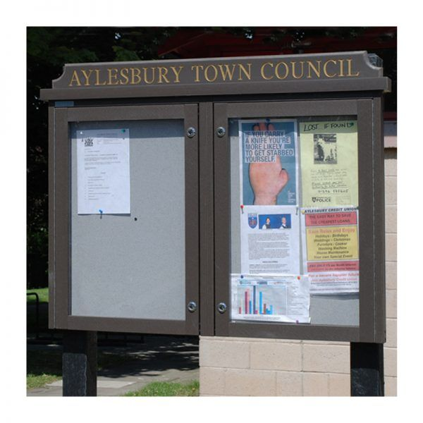
Lettering in white vinyl
Lydiard Millicent Parish Council

848mm high

Mounting Posts
Black Square 100mm
Height dependent on ground,
overall length of pole 2500mm

Please could you confirm your acceptance of the Council using your land before the next council meeting on 4th March 2021, when a final decision about placement of the Noticeboard will be taken. If you require any further information please do let me know.

Kind Regards Deborah Bourne

Reply from Chairman of Parish Hall Trustees 15 February 21

Dear Deborah,
Thank you for your mail about the notice board. The position of the board was agreed previously that it would be more towards the entrance to the Parish Hall (see attached) The pavement there is wider and it would be safer for anyone looking at the notices.
The wording at the top of the board would be better just saying “ LYDIARD MILLICENT PARISH” as half of the board would be used for community notices. This was discussed the last time this subject came before the council.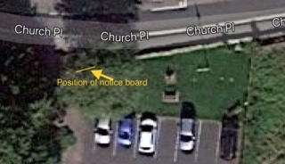 Regards Mike
Reply from Treasurer to Parish Hall Trustees – 1st March 21

Hi Mike
I don’t mind too much what it says. It’s the position of the board that is important. They put it where we say, or it doesn’t go up.

Below is the original mail to us asking for formal approval for the board, and it clearly states that the lettering will be in WHITE VINYL, so it should be easy to cut off the worn Council if we insist.
A way out would be for them to put a banner inside their half along the lines of ‘ Official Notices Only ‘ and in the other side ‘ General Parish Information ‘ or words to that effect.

I think we must stress that the board must be kept up to date, and old notices removed regularly. It may help if we had a spare key for their side so we could keep an eye on it as well.

Roy

Next Steps

- The Council is asked to authorise the expenditure of £40 for informal advice from the planning department, and to authorise further application fees if it is necessary to obtain formal permission to site this noticeboard in the conservation area.

- The Council is also asked to consider the requests made by the Parish Hall to remove the word Council on the heading plate and to supply a spare key for hall Trustees (one side only is locked).

Deborah Bourne
Clerk/RFO

